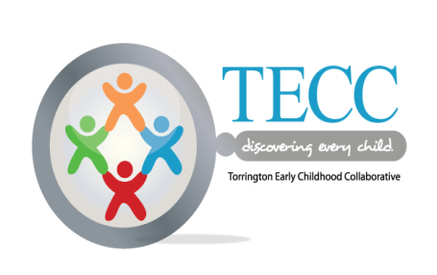



**The Northwest Collaborative for Families and Young Children**

A Local Interagency Coordinating Council (LICC)

CT Birth to Three System

In partnership with

Torrington Early Childhood Collaborative

Child Growth & Development Workgroup Meeting

**March 17th, 2016**

Location: BROOKER MEMORIAL

157 Litchfield Street

**9:00 – 11:00 a.m**.

AGENDA

1. Introductions
2. B-3 State Update
3. TECC Update
4. LICC - Technology Parent Session

Impact of Technology on Young Children

April 26- Tuesday

6-8 PM

Vogel Wetmore Cafeteria

May Parent Session (Transition?)

1. CHILD FIRST
2. Community Sharing

Next Meeting April 21st

2015 – 2016 Calendar Attached





**The Northwest Collaborative for Families and Young Children**

A Local Interagency Coordinating Council (LICC)

In partnership with

Torrington Early Childhood Collaborative’s Child Growth & Development Workgroup

2015 -2016 (School Calendar Year) Meetings

Location: Location: BROOKER MEMORIAL

157 Litchfield Street

**9:00 – 11:00 A.M. Third Thursdays of the Month**

Sept. 17

Oct 15 – Brooker Memorial

Nov 19

Dec 17

Jan 21

Feb 18

March 17

April 21

May 19

June 16

F TORRINGTON PUBLIC SCHOOLS ARE DELAYED OR CANCELLED MEETINGS WILL BE CANCELLED